References for Major Project 1:

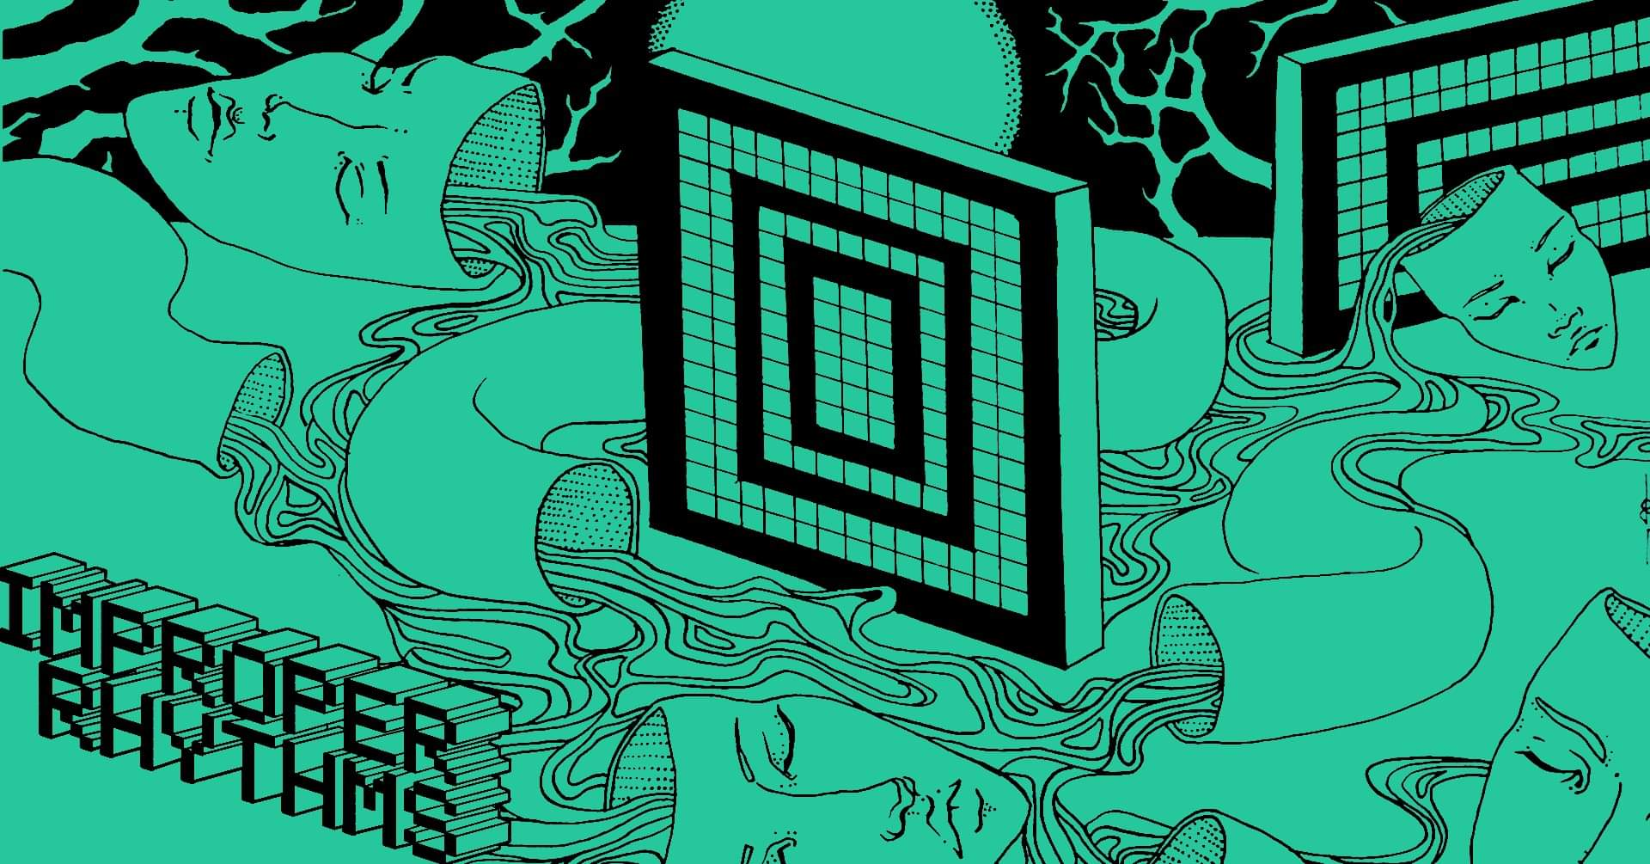

Source: <https://wallpapercave.com/w/wp11183848>

Found on: Line 3 of main.css



Source: <https://www.onlygfx.com/gold-picture-frame-png-transparent/>

Found on: Line 36 of main.css



Source: [sewerslvt_1598882320.jpg (640×640) (albumoftheyear.org)](https://cdn.albumoftheyear.org/artists/sewerslvt_1598882320.jpg)

Found on: Line 29 of index.html

Source: [0015164717_10.jpg (1000×1000) (bcbits.com)](https://f4.bcbits.com/img/0015164717_10.jpg)

Found on: Line 36 of index.html

Source: [0001461302_10.jpg (500×523) (bcbits.com)](https://f4.bcbits.com/img/0001461302_10.jpg)

Found on: Line 43 of index.html

Information found courtesy of Wikipedia and YouTube (I guess? This one only really applies because I know subgenres and some artists because of YouTube, so…)